Bryan Guner

1.

A.)

Using KVL and knowing current through a capacitor = C $\frac{dV\text{c(}\text{t)}}{dt}$ in tandem with the fact that current is constant in a series circuit. the total voltage will equal the sum of the voltages in the capacitor and resistor. Since the values of the input V(t) and output Vc(t) are given the only voltage to solve for is that of the resistor. We use ohms law V=IR and multiply C $\frac{dV\text{c(}\text{t)}}{dt}$ by R.

B.)

The system is casual because the output only depends on present values of input and because the model is of a physical system.

The system is time invariant because it is a First Order ODE

Linear:

$RC\left[\frac{d}{dt}\left(a1*Vc1\left(t\right)+a2*Vc2\left(t\right)\right)\right]+a1*Vc1\left(t\right)+a2*Vc2\left(t\right)=a1V1\left(t\right)+a2V2\left(t\right)$

$a1[RC(\left[\frac{d}{dt}\left(Vc1\left(t\right)\right)+Vc1\left(t\right)-V1\left(t\right)\right]=a2[RC(\left[\frac{d}{dt}\left(Vc2\left(t\right)\right)+Vc2\left(t\right)-V2\left(t\right)\right]=0$

Since $RC(\left[\frac{d}{dt}\left(Vci\left(t\right)\right)+Vci\left(t\right)-Vi\left(t\right)\right]=0 when i=1,2$

Each component of the equality is equal to 0 and therefore satisfies principle of superposition and is therefore linear

C.)

$Vc\left(t\right)=u\left(t\right)-.5*0.25(\frac{dVc\left(t\right)}{dt})$

$$when t>0$$

$$Vc\left(t\right)=1-0.125\left(\frac{dVc\left(t\right)}{dt}\right) 0=-0.125s$$

$$so Vc\left(t\right)=Ce^{-8t}+1$$

When t < 0

$$Vc\left(t\right)=-0.125\left(\frac{dVc\left(t\right)}{dt}\right) 0=-0.125s-1 s=\frac{1}{.125}=8 Therefore so Vc\left(t\right)=Ce^{-8t}$$

2.

A.)

The system is casual because output depends on a past value of input.

The system is time invariant because

y(t)=x(t-1-t0) y(t-t0)= x(t-t0-1)=y(t)

linearity:

a1\*y1(t)+a2\*y2(t)=a1\*x1(t-1)+a2&x2(t-1)

a1[y1(t)-x1(t-1)]+a2[y2(t)-x2(t-1)]=0

since yi(t)-xi(t-1)=0 when i=1,2

Both parts equal 0 so it satisfies principle of superposition and is therefore linear

B.)

$h\left(t\right)=\int_{-∞}^{∞}{x\left(t-1\right)dt=u\left(t-1\right) when t>1=1 when t<1=0}$

C.)

$y\left(t\right)= \int_{-∞}^{∞}{h \left(τ\right)*x\left(t-τ\right)dτ= }\int_{-∞}^{∞}{h\left(τ\right)*e^{j\left(t-τ\right)}dτ=e^{jt}\int_{-∞}^{∞}{h\left(τ\right)e^{-jt}dτ=e^{jt}*H(t)}}$

3.

A.)

$\frac{d}{dt}[y\left(t\right)=\int{\frac{1}{L}*x\left(t\right)-\frac{R}{L}*y\left(t\right)dt]=y'(t)= \frac{1}{L}*x\left(t\right)-\frac{R}{L}*y\left(t\right)dt}$

B.)

Using KCL

$\frac{Vi\left(t\right)}{R}+\frac{CdVo\left(t\right)}{dt}=0 \frac{Vi\left(t\right)}{RC}=-\frac{dVo\left(t\right)}{dt} Vo\left(t\right)=-\frac{1}{RC}*\int_{-∞}^{∞}{Vi\left(t\right)dt}$

C.)

$if R*C=1 then Vo\left(t\right)=-\int_{-∞}^{∞}{Vi\left(t\right)dt}$

Setting R\*C=1 cancels out the (1/RC) coefficient of the integral, and putting the output through the inverting terminal of an op-amp with unity gain in order to change the polarity of the voltage will satisfy the equation below.

$$Vo\left(t\right)=\int_{-∞}^{∞}{Vi\left(t\right)dt}$$

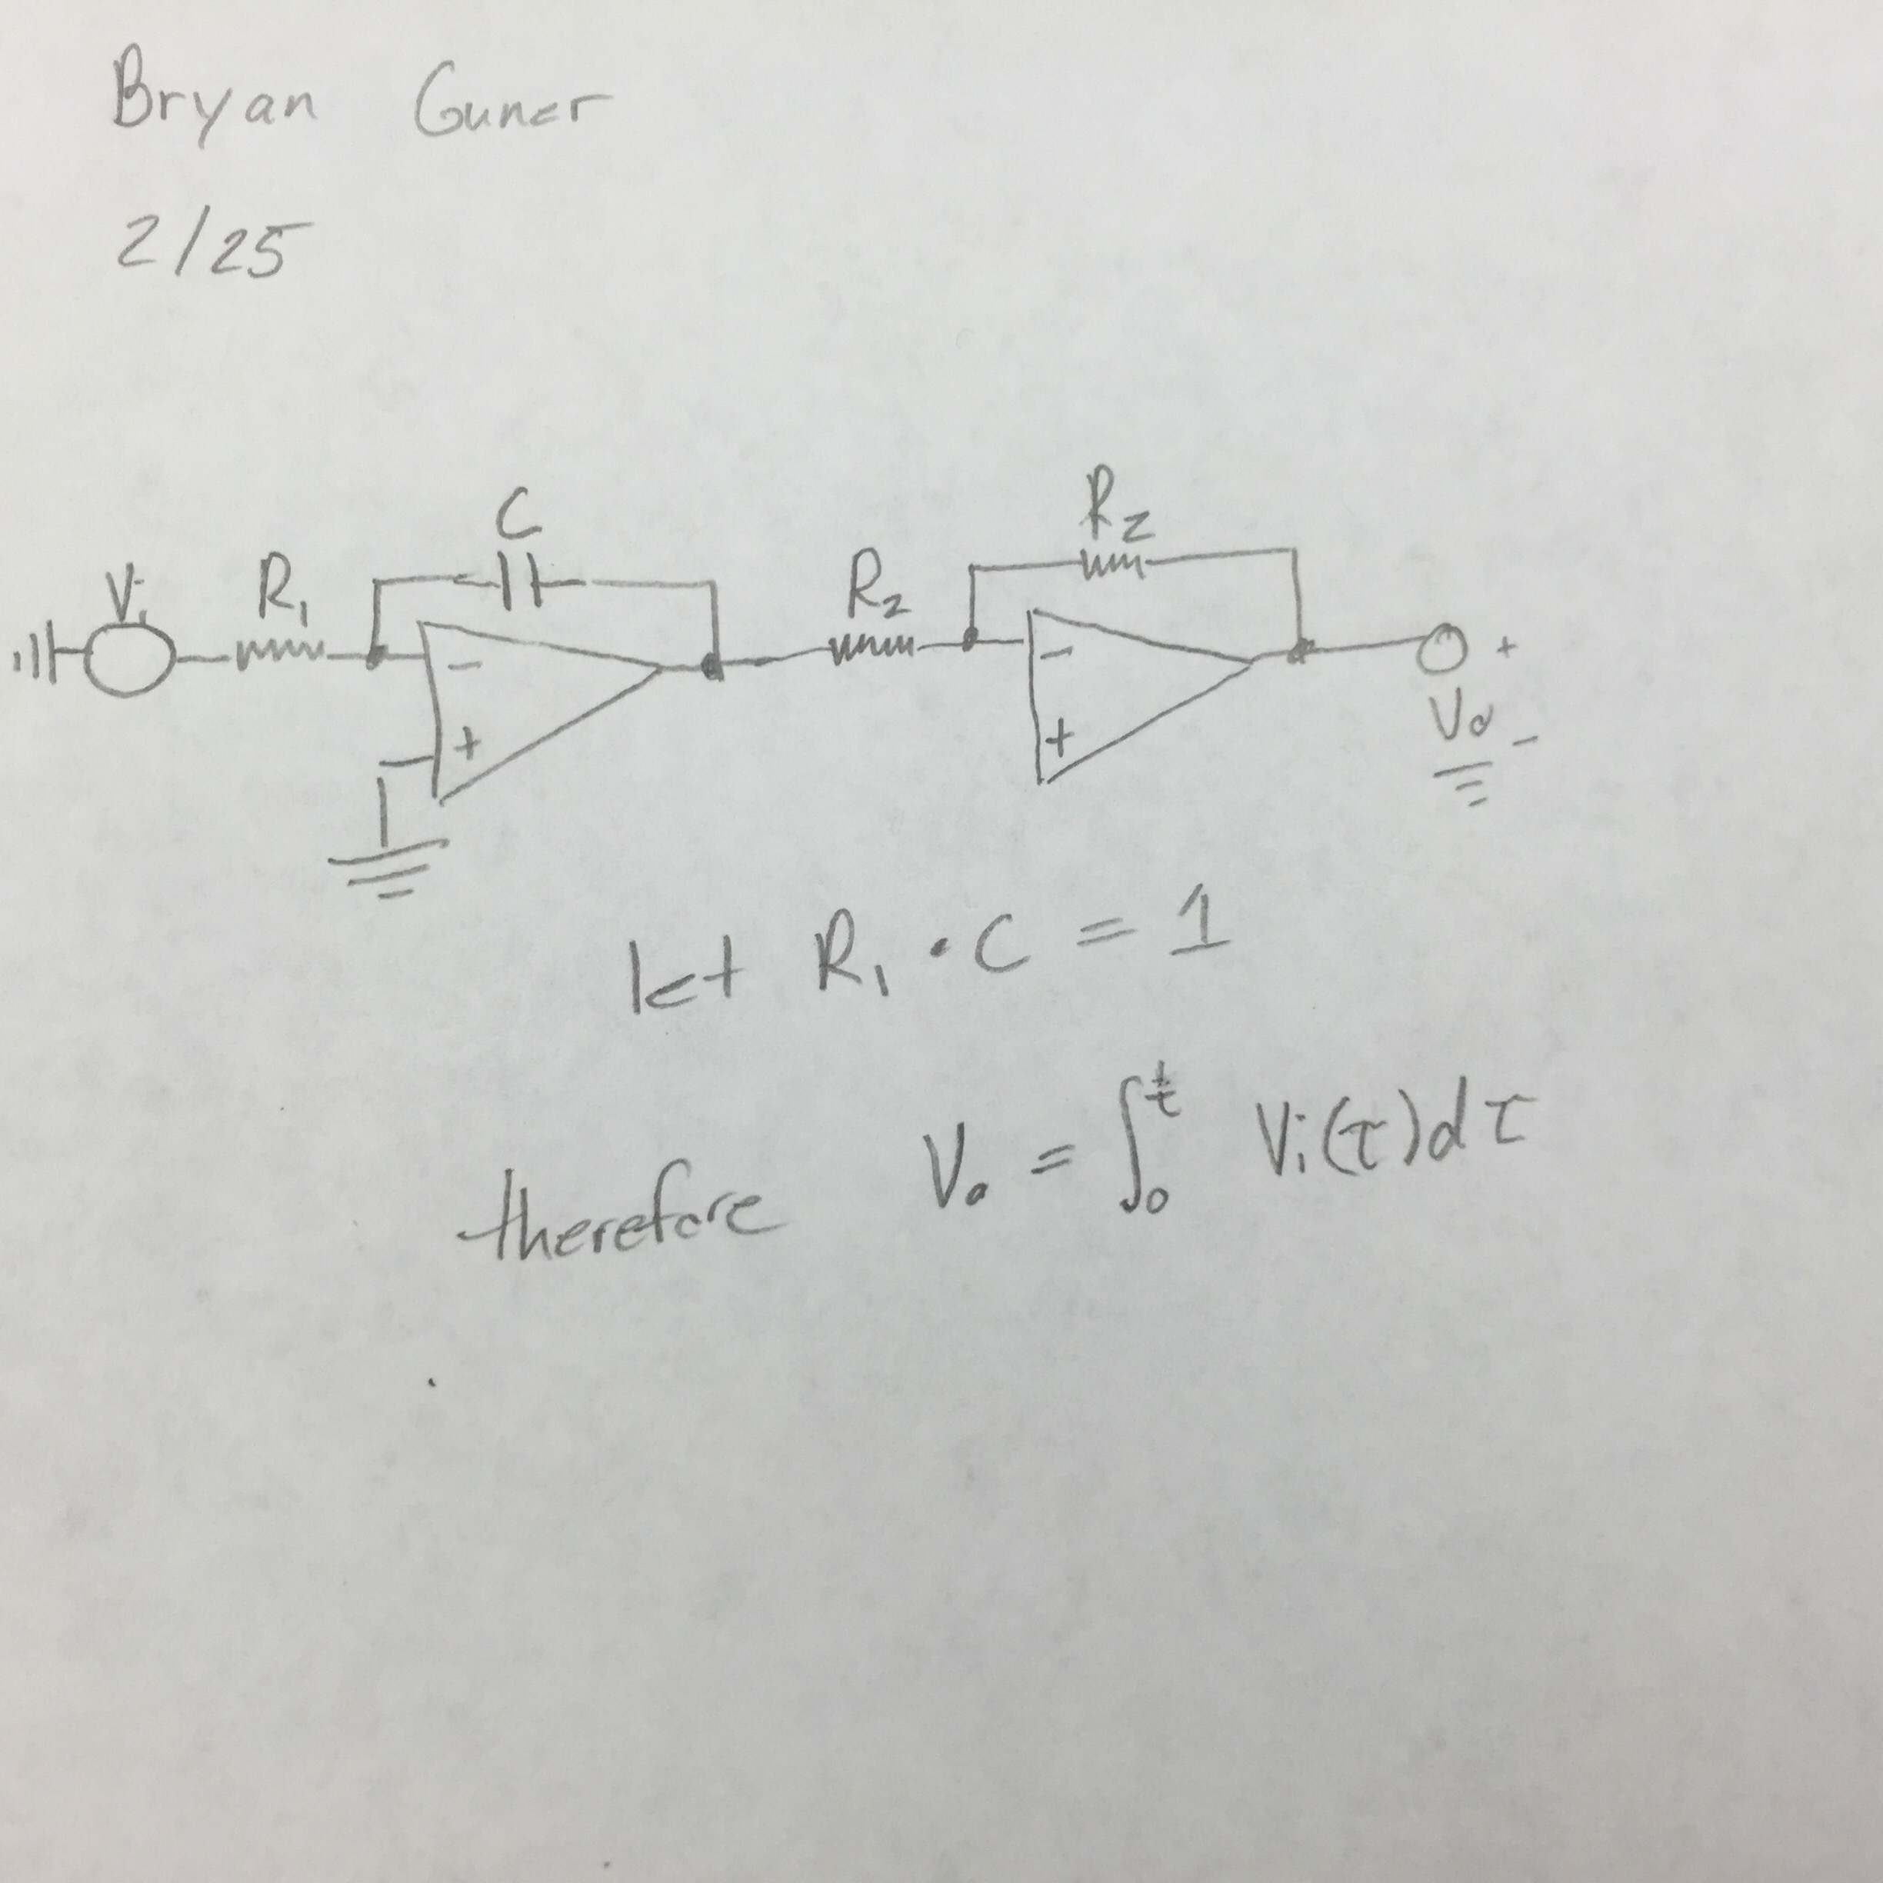

4.

A.)

$y\left(t\right)=\int{(}\int{10x\left(t\right)-5y\left(t\right)-6\int{(y\left(t\right)dt)dt)dt}}$

$y^{\left(2\right)}\left(t\right)=10x\left(t\right)-5y\left(t\right)-6y'(t)$

B.)

$y^{\left(2\right)}\left(t\right)+5y\left(t\right)+6y^{'}\left(t\right)=10x\left(t\right)$

$s^{2}+6s+5=0 => \left(s+1\right)\left(s+5\right)=0 => s=-1,-5$

5y(t)=10x(t) => 5s=10 => s=2

$yc\left(t\right)=2+c1e^{-1t}+c2e^{-5t}$

For y(0)=-1 $-1=2+$ c1+c2 -3=c1+c2

For y’(0)=0 $0=-c1-5c2 => c1=-5c2$

After solving $c2=\frac{3}{4} c1=-\frac{15}{4}$

$yc\left(t\right)=2-\frac{15}{4}e^{-1t}+\frac{3}{4}e^{-5t}$

C.)

t=0:0.0001:20;

y=(-3.75)\*exp(-t)+(0.75)\*(0.75)\*exp(-5\*t)+2;

plot(t,y,'linewidth',2)

axis([0 20 -2.5 2.5])

title('4.c')

xlabel('t')

ylabel('Y(t)')

grid

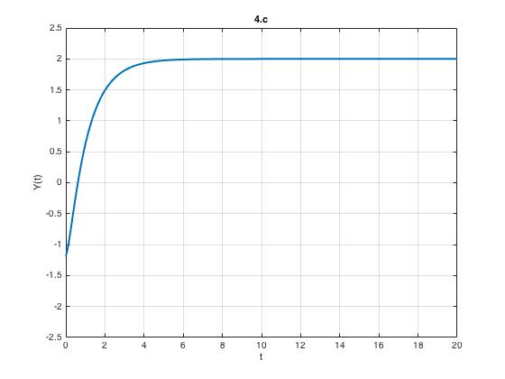

D.)

figure

y=dsolve('D2y=(-6)\*Dy-5\*y+10','y(0)=-1','Dy(0)=0');

ezplot(y)

grid

axis([-1 7 -3 3])

title('4.d')

xlabel('t')

ylabel('solution')

